Googly Eye Finger puppets

What you need:
- pipe cleaners (1 makes 3-puppets if the googly eyes have hooks on the back. 1 pipe cleaner makes 4 puppets if you glue the googly eyes onto the pipe cleaner)
- Large-ish googly eyes (2 per puppet)
- Hot or cold glue gun
- Scissors

What you do:
1. Cut the pipe cleaners into 3-4 pieces each and bend up the ends.

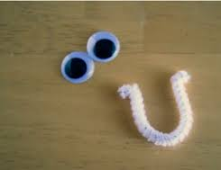

2. Either thread each side of the pipe cleaner through the hooks on the eyes or glue the eyes to each end of the pipe cleaner piece.

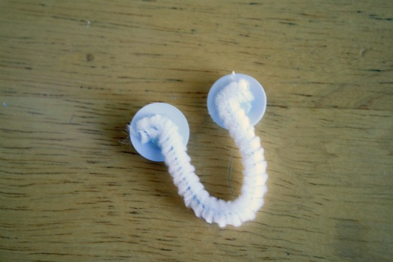

3. Slip the puppet onto your middle finger and use your fingers to ‘talk’

